**The Grand Heist**

**Story**

The story of The Grand Heist is the player is a modern-day burglar that is known in the dark web as able to rob any person no matter the difficulty. The client requests that he has live footage of the burglar breaking into the requested place as he has intel that can help break in but he won’t reveal why he won’t give them to the burglar. As the player moves in though the billionaire’s office, the player will pick up clues on who he is robbing and will learn about his pain, passion and his perseverance. At the end of the level, you will finally learn what you are robbing and it isn’t what you will rob but what you have robbed already as the player has taken something dear from the billionaire who is indeed the client.

**Setting**Even though I won’t be designing the exterior of the museum, this is what I am thinking the museum would somewhat look like. The museum would have a modern look because a billionaire recently designed it and had it created for the sole purpose of hiding his most important treasures and secrets.

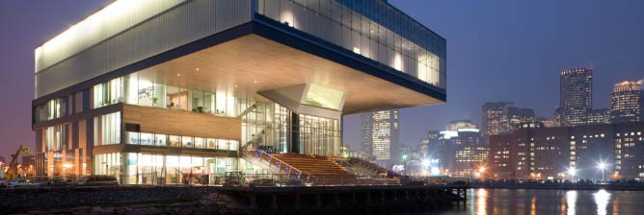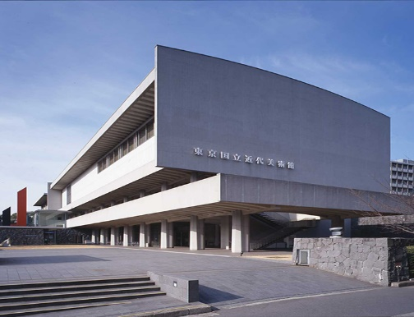

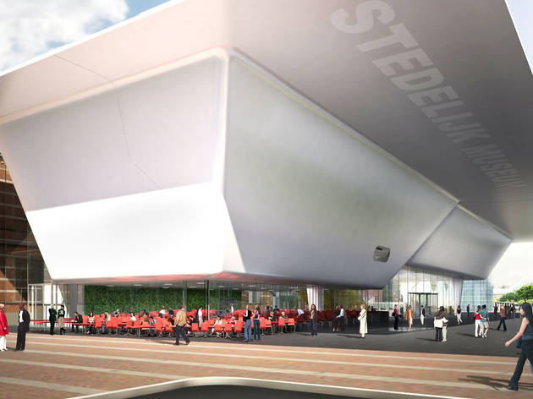

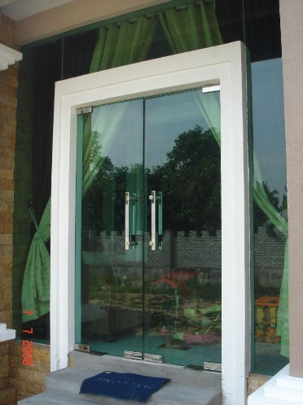

Even though the player will be inside the museum at night, this is what the entrance door and the rest of the doors will look like while inside the museum. The doors will be locked and you will only see this door once as the doors will be locked and the room is closed off by this only door.

**Room 1 – Starting Area**

Door

This is how the entrance would normally be but there will be locked doors in the way and the ceiling will have a hole from the top to indicate that the player came from the ceiling.

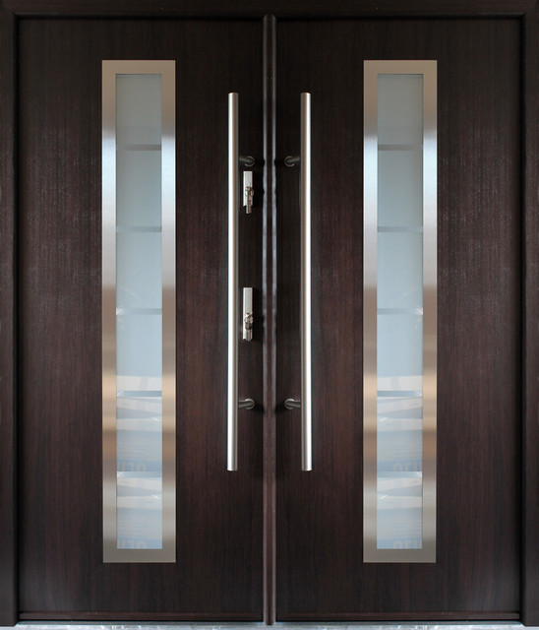

The handles will be long steel bars that take up roughly 2/3 of the doors to give it the museum feel as I have personally been to many museums that have the double door steel beam handles.  
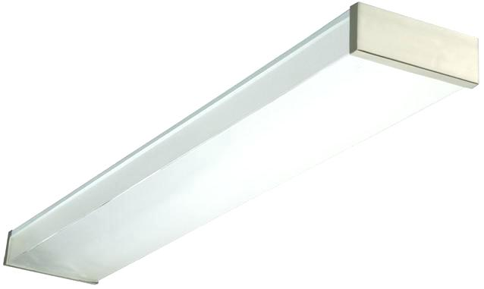

The main celling lights will be long and will be the length of the room, however since the museum is closed these lights will not be on until the player presses the hidden button on the bait picture which lights up the whole room and causes an alarm to ring.



However, the paintings will be highlighted with spotlights and these spotlights will cover the room as well so the player can see where they are walking but not bright enough to see the minor details like writing on the picture captions.

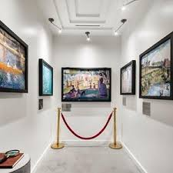  
This picture was chosen because I loved the idea of a bank heist not being in an actual bank but rather in an actual modern building where many public people go for enjoyment and not to do chores with their actual money. Who would have guessed that a very valuable treasure belonging to the owner would be in their actual museum instead of in their home? This picture also heavily inspired the design for the first room of the puzzle room where nothing is out of the ordinary.

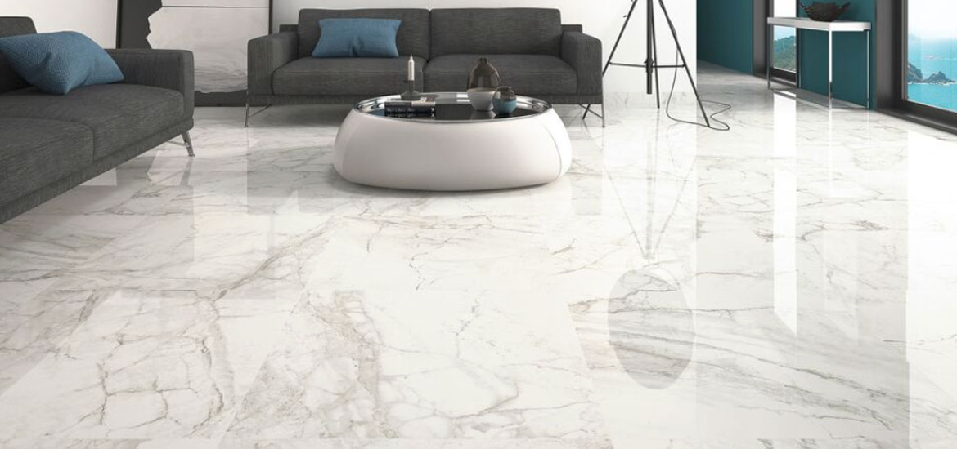

The floor of the first room will have a marble material a marble flooring is one of the most beautiful types of floors in the world and is normally the typical flooring in modern public buildings.

**Painting Design – First Room**  
Considering I am such a poor painter/drawer/artist/all the above, I will be using some free to use art that all have the theme of family. Family is a very important theme that the majority of people in the world have had at some point or another whether they are blood relatives, friends you have been with your whole lives or just one person who brought you up. Family is a vital part of our lives but when our billionaire doesn’t grow up with one then he does not know how it feels to be loved from a young age.  
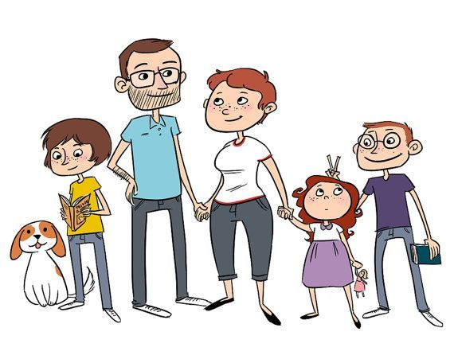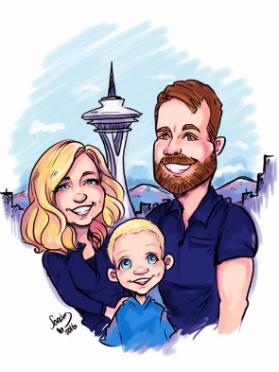

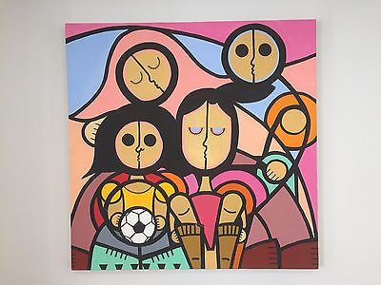

These won’t be the final paintings that are used in actual project but they all follow the theme of family apart from one which will be the contrast the other photos and that will be the one that lets the player into the vault.

**Room 2 – Main Area/Clue Area**

This is the room where the most puzzles and the story will fully start. The room is much different than the first room. It no longer looks modern but now looks a lot more natural with all the wood furnishings. The inside of the main Kingsman office in Kingsman: The Secret Service as it has majority wood furnishings. Wood furnishings give off a very warm and rich atmosphere and this is exactly the type of atmosphere The Billionaire is looking for to compensate for the missing love and gifts that his family would have given him.  
  
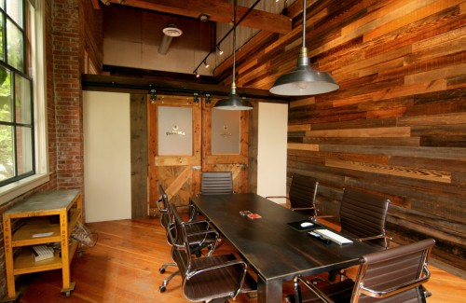 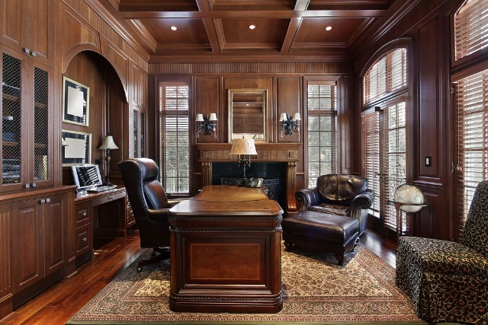

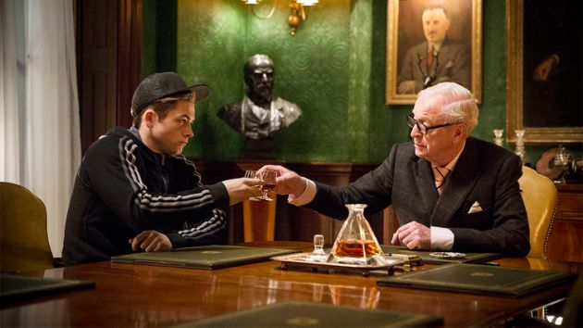 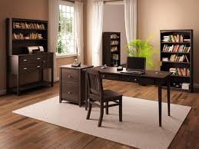

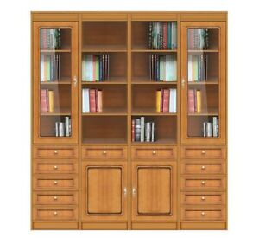The furniture is going to follow a distinct pattern of wood that could be from Oak to Birch. Since the room is going to be underground, it might fit the setting of it being an office being underground if we were to use darker wood in the more lit areas and lighter wood in the darker areas to create a contrast and make everything equally stand out more.

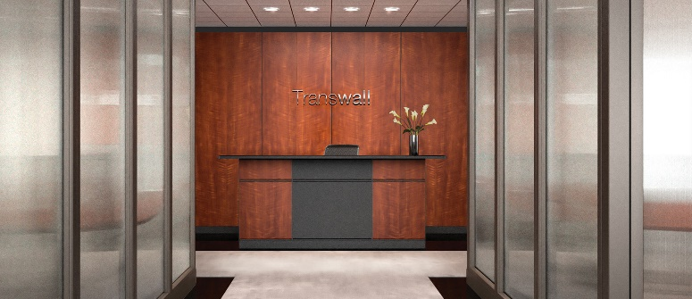

The office walls will be much like the colour and pattern of the wooden wall here, the dark wood gives a nice glossy look along with a smooth appearance and feel along with the knowledge that a quality craftsman created this.

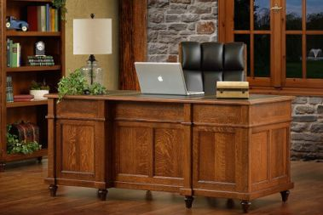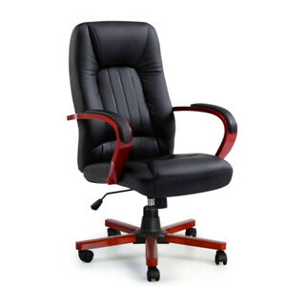

The desk would be something similar to this. The sort of desk like this mostly creates the image of how grand the office will be, the more aesthetically pleasing and expensive the desk is can make the office. The material, finish and pattern on the desk is how you can tell how expensive the desk is.  


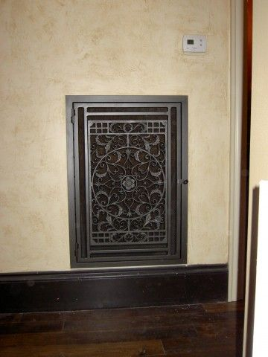  
The room has a vent for if The Billionaire wants to smoke his cigar inside main room then he can do and have the vent filtrate the smoke out before it stains itself onto the furniture. An engraving like this will go well with the wall.

The wooden floor can’t be to glossy if it’s going to fit into an office that has contrasting wood so why not have a wood floorboard that has both and looks rich and not tacky.

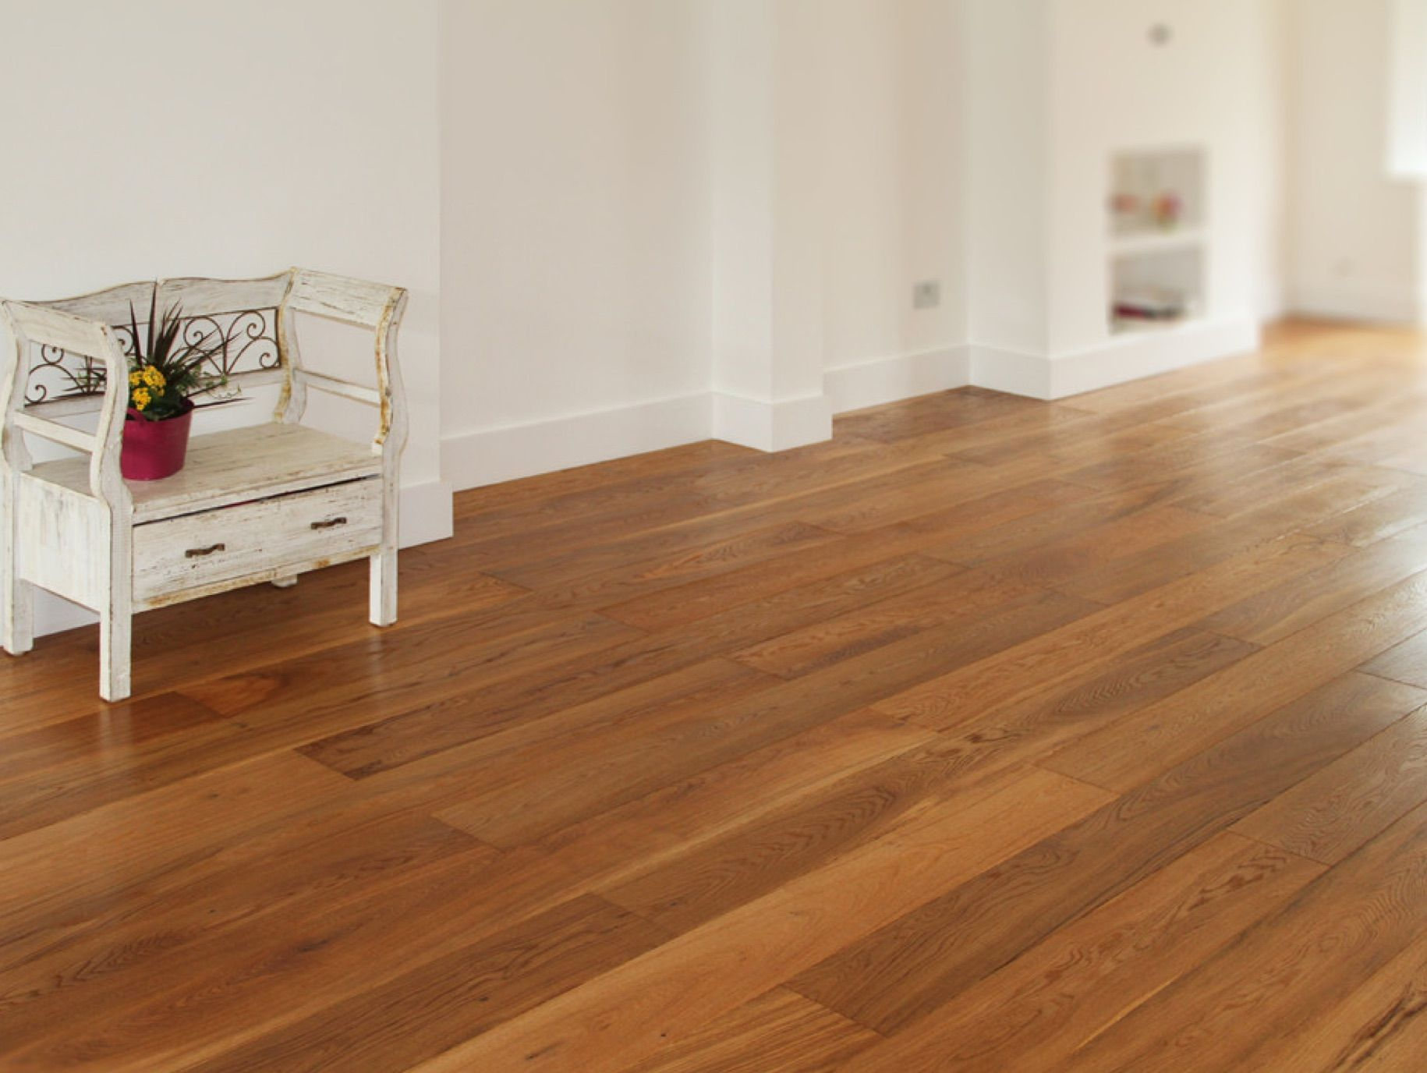

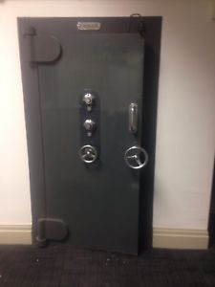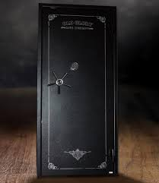  
The safe door will be inside the room and the safe door was installed in case any employees caught him from entering his secret office and they would try to snoop. The billionaire can’t be too careful but not too secretive in case someone enters and sees a not to overbearing safe door.

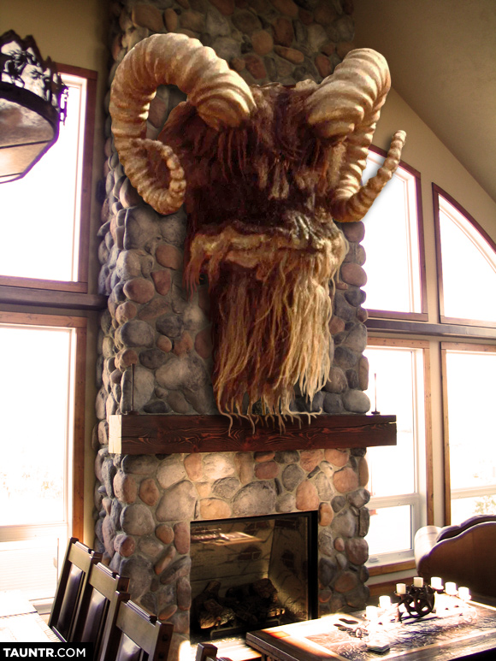

Just like most gentleman’s club room or office, there will of cause be some kind of trophy and above a very nice-looking stone fireplace.

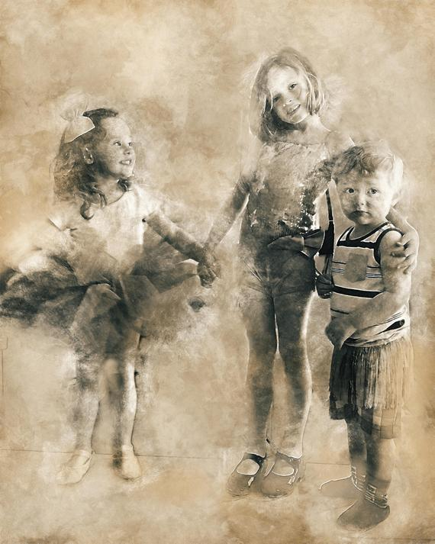

This room will only have one painting in it but it will be related to a puzzle without it actually being interactable. The theme is family and so its only suitable if we have a grand painting in the office about it.

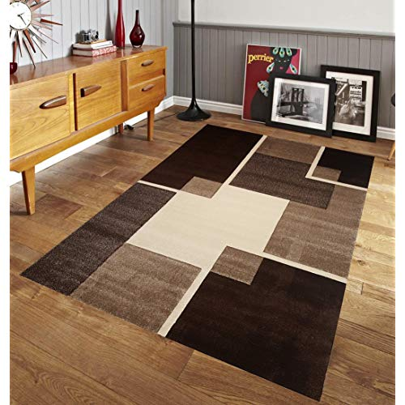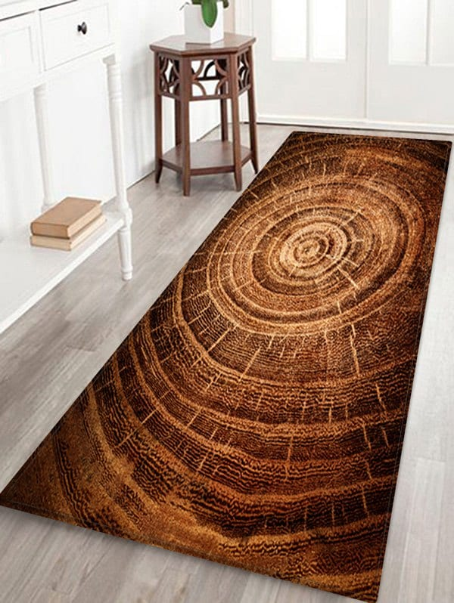

Our billionaire really likes wood so why not have a wood rug or anything that matches up with a wooden floor.

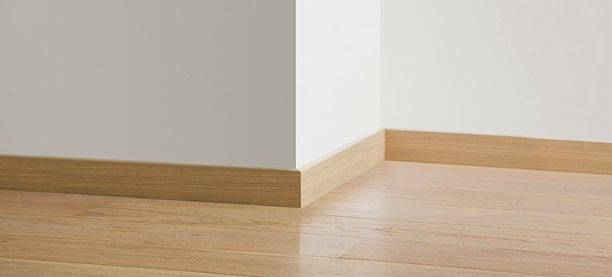

Even though this won’t be what the skirting boards look like, I love the idea of the skirting board being the same colour/material as the floor so this has made me think that this is the best for having a rich looking room.

**Room 3 – Treasury Room**

The treasury room won’t be much different from an actual deposit box room. The room will pretty much be like this from the ceiling lights to the marble floor purely because it matches up with the first room of it being modern like.

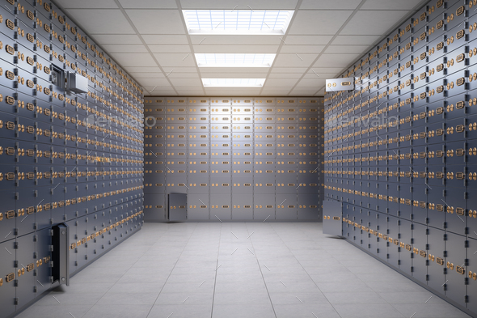

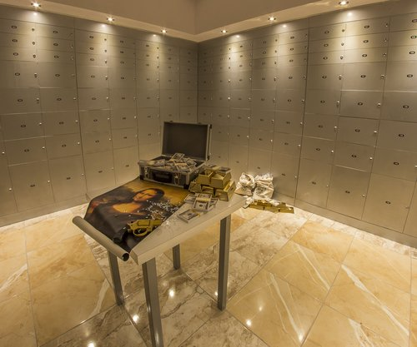

Like most valuable prizes, you are going to put the most valuable in the middle of the room for easy access. It’s not like you expect anyone to break into the vault anyway.

**Sounds and Animations**

Here are some sounds you will most likely hear or will be similar in hearing in The Grand Heist.  
  
<https://www.youtube.com/watch?v=HFl0kEuvpNI-> AC humming  
  
<https://www.youtube.com/watch?v=ys9orzlFxAA> La Noir Correct Jingle  
  
<https://www.youtube.com/watch?v=Bj5PgdhuVuU> – Wind Howling  
  
<https://www.youtube.com/watch?v=TwrxDV-HF1E> – Safe door unlock with Keycode Input  
  
<https://www.youtube.com/watch?v=IHMkdBmyqdI> – Safe Door being unlocked

|  |  |  |  |  |  |  |  |
| --- | --- | --- | --- | --- | --- | --- | --- |
| # | | **Name** | | **Type** | **Description** | **Length** | **Requirements** |
| **1** | | Footstep - Marble | | Diegetic | The player walks in any direction on the marble floor to create a sound from it | 1/2 second | Must loop fluidly |
| 2 | | Footstep – Wood floorboard | | Diegetic | The player walks in any direction on a wooden floorboard to create a sound from it | ½ second | Must loop fluidly |
| 3 | | Footstep - Carpet | | Diegetic | The player walks in any direction on a  carpet to create a sound from it | ½ second | Must loop fluidly |
| 4 | | Vent- Humming | | Diegetic | When the player reaches the second room, there will be a steady and soft hum from the vents | Continuous | Will loop fluidly in a range |
| 5 | | Big Painting Door Button – Alarm | | Diegetic | When the player has pressed a button, the alarm will be raised to tell the player he has been caught | 5 Seconds | Must loop fluidly |
| 6 | | Small Painting- Door Unlock | | Diegetic | When the player has pressed a button on the small painting, the door behind the painting will play an unlock sound | 1 second | Will be played once |
| 7 | | Crickets Singing- Outside | | Non-Diegetic | Crickets will play their sound the closer you are to the windows on the walls | Continuous | Must loop fluidly |
| 8 | | Wind howling | | Non-Diegetic | Wind will howl occasionally when you move next to the windows on the walls | 2 Seconds | Must play with no interruption but must not be too overbearing |
| 9 | | The Client Talking | | Diegetic | The client will talk to the player now and then to give clues to the player | Varied | Clients voice must be heard cleanly with no interruptions from any other sounds |
| 10 | | Piano Sound – Puzzle solved | | Diegetic | This sound will play when the player has solved a puzzle | 2 Seconds | Sound will be played and can’t be interrupted by any sounds so the player knows they have solved the puzzle |
| 11 | | Big Safe Door- Unlocked | | Diegetic | When the player has gathered the clues and has pressed in the keycode, the big door to the treasury room will unlock | 2 seconds | Must loop cleanly |
| 12 | | Keycode- Button Press | | Diegetic | When typing in the door keycode, a sound will play to indicate you have pressed it | 0.3 seconds | Must loop cleanly |
| 13 | Small Safe Door – To important treasure | | Diegetic | | The small safe door to the actual safe will unlock when you prompt the door. | 0.3 seconds | Must loop cleanly |

**User Interface**

The user interface will include a menu for the player to scroll through and will include the options:  
  
Start  
Options  
Leaderboard  
Exit

For the user interface, I was of cause thinking of using a soft font that museums would use because its easy to look at and soft to the eye and would fit into the museum if they were to be placed in there. This is what the subtitles for the client may use and how the user will be prompted for a button press when near an item of importance.

